Technical Blueprint

Enschede, 1 January 2026
Version 1.0
Prepared by: | Class: EMT2 C/D | Group: 3
 | Anjo Bouwmeester  Javier Arredondo  Dylano Schepers  Chiosa Valeriu | 556058  587509  591532  534507

1. System Scope and Operational Intent 2
2. Control Responsibilities and Architecture 2
3. Safety Considerations and Quantitative Assessment 4
3.1. Methodology: The Safety Assessment Algorithm 4
3.2. Application to the Coil Mover Concept 7
3.3. Concept Assessment Status 8
4. Path to increase the SRI score 9

System Scope and Operational Intent

The proposed system automates the outfeed operations of the existing coil winding machine. The main objective is to extract coils from a full cartridge, inspect them individually, and sort them based on quality. Compliant ("OK") coils are moved to specific positions to the box packing station, while non-compliant ("NOK") units are moved to a rejection bin. The design is divided into four functional modules: the robot, the inspection station, a turntable for changing cartridges, and the box handling system.
A key point of the design is the original winding machine can contain minimal changes. This is the reason why instead of changing the software or cabling, a “mechanical simulation” method is used: it physically pushes a sensor on the winder to act as a operator resetting it. This allows us to keep the production going while keeping the machine with minimal modifications.

2. Control Responsibilities and Architecture
The software is divided into three main parts: the robot control, the inspection system, and the main PLC.
Robot Control: The robot runs pre-programmed motion paths based on specific pick-and-place coordinates. It talks to the turntable and inspection camera via TCP/IP. The safety zones and movement limits were directly set on the robot’s teach pendant.
Inspection system: It manages the sequence of steps between stations, controls safety locks, and handles the HMI screens (including start/stop buttons, mode selection, recipes, and alarms).
PLC: This system works independently to check the quality of the part and sends the result (Good or Bad) back to the main control.
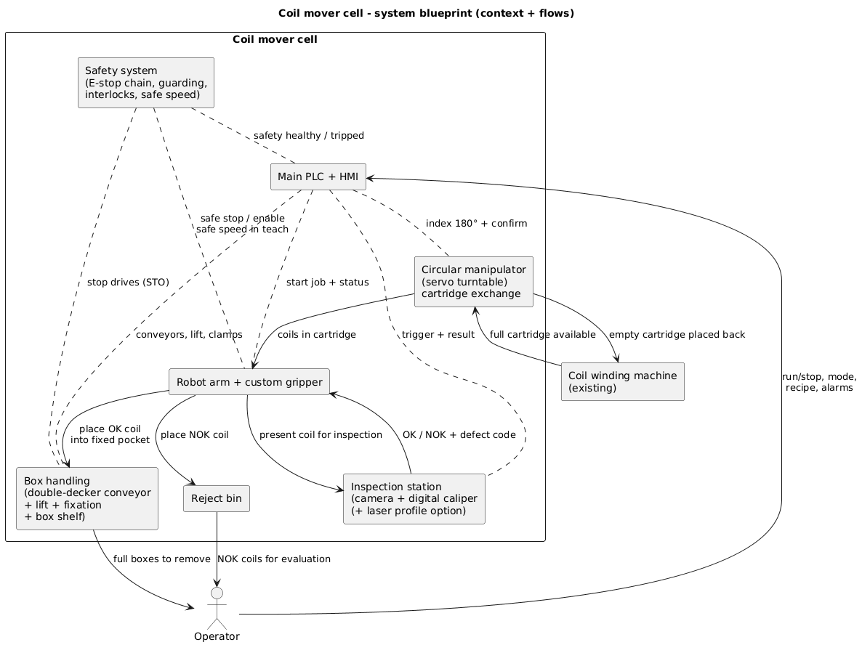Figure 1: System Topology and Material Flow. This diagram illustrates the physical flow of materials alongside the primary control links. It highlights the segregation between standard process control (PLC/Robot/Inspection) and the overlying safety systems.
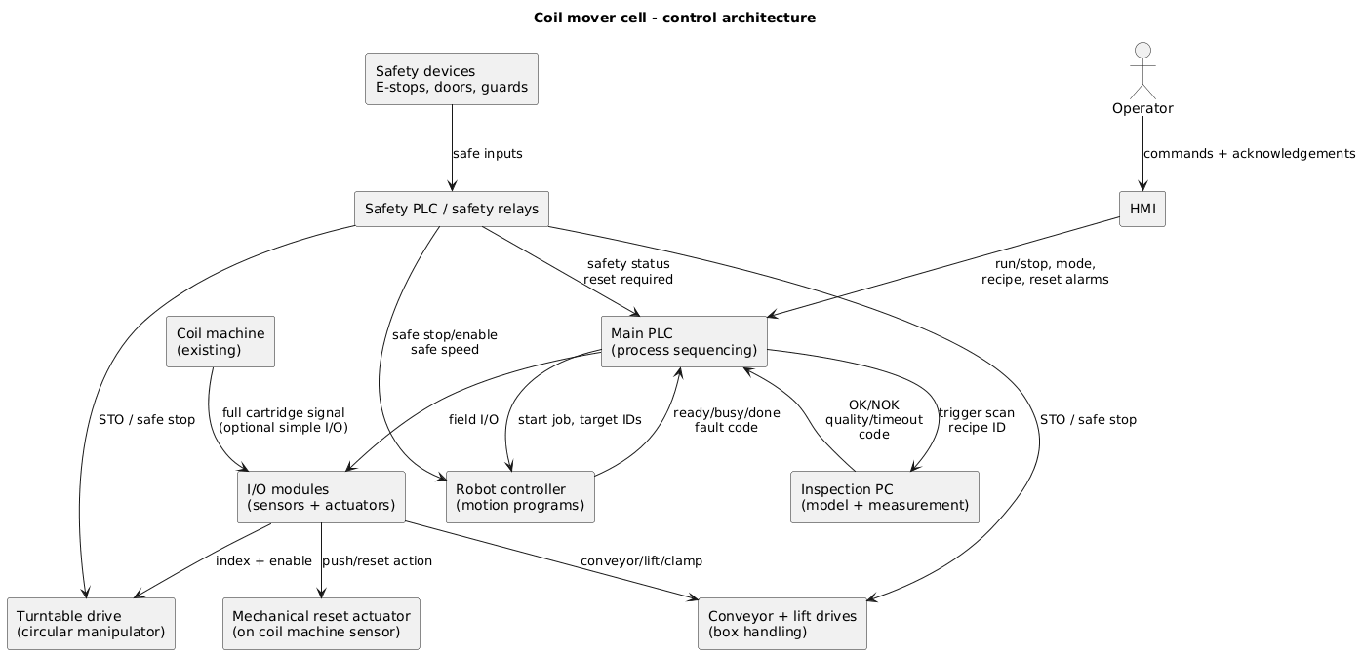Figure 2: Control Authority Allocation. This schematic delineates command responsibilities: The PLC manages the process state, the robot controller governs motion execution, and the inspection unit handles measurement and classification. Safety logic remains physically and logically independent from the standard PLC program.
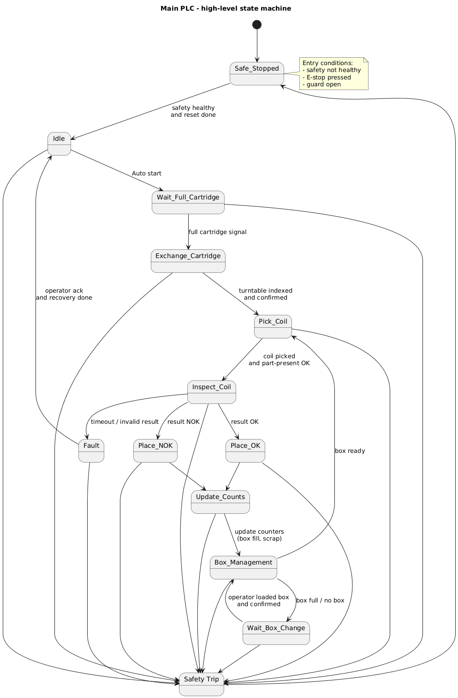 Figure 3: PLC Finite State Machine (FSM). The process sequence is engineered such that every transition is gated by both safety status and station readiness. Following any safety violation, the system defaults to a defined "Safe State," necessitating an explicit manual reset to resume operations.

3. Safety Considerations and Quantitative Assessment
While the baseline requirements stipulate an E-stop chain, interlocked guarding, and reduced velocity modes for maintenance, this blueprint applies a formal assessment algorithm to translate those requirements into measurable pass/fail criteria and a graded maturity score.

3.1. Methodology: The Safety Assessment Algorithm
Step 1: Hazard-Based Risk Scoring

The safety of this machine is built on three main layers. First, Physical Separation: the robot and turntable are fully enclosed in a safety fence, so operators cannot accidentally touch moving parts. Second, Independent Monitoring: a dedicated Safety Controller monitors all E-stops and door switches. This controller is separate from the main PLC, meaning a bug in the standard software cannot disable safety features. Third, Safe Power Cut: if a door is opened or an E-stop is pressed, the Safety Controller cuts power to the motors using "Safe Torque Off" (STO). This guarantees the machine stops immediately and cannot restart until the system is reset.

To ensure clarity and accountability for stakeholders, each identified hazard is assigned a numeric risk score based on four factors (scaled 1–4):
- S (Severity): 1 (Minor) → 4 (Fatal/Permanent)
- F (Frequency/Exposure): 1 (Rare) → 4 (Frequent/Continuous)
- P (Probability of Occurrence): 1 (Unlikely) → 4 (Likely)
- A (Avoidance): 1 (Easy) → 4 (Hard)
The Risk Score (R) is calculated as:
R = S × F × P × A
Risk Classification:
- 1–15: Low
- 16–63: Medium
- 64–127: High
- 128–256: Critical
Validation Rule: Any hazard classified as "Critical" must be mitigated by a dedicated safety function. Failure to do so makes the machine concept unacceptable.
Step 2: Mandatory "Gate Checks"
Despite of the numeric score, the following functional requirements serve as pass/fail gates for the concept review:
- E-Stop Chain: Must stop all hazardous motion (robot, turntable, conveyors, lift).
- Interlocks: Guarding must prevent automatic operation when opened.
- Safe Speed: Motion during Teach/Maintenance modes must be velocity-limited with controlled enabling.
- Restart Prevention: No unexpected startup following a safety stop; explicit reset is mandatory.
- Drive Interface: Safe Torque Off (STO) or equivalent required for turntable and box handling drives.
- Mode Separation: Distinct separation between Auto and Manual/Teach behaviors.

Step 3: Safety Readiness Index (SRI)
To assess the safety concept, a 0–30 scale is applied across six pillars (scored 0–5 each):
- P1: Risk assessment quality.
- P2: Coverage of safety functions.
- P3: Independence of safety architecture.
- P4: Robustness of the validation plan.
- P5: Documentation and procedures.
- P6: Recovery and maintainability strategies.
With the following ratings
- 0–14: Not Acceptable.
- 15–20: Conditional (Concept valid, but gaps exist).
- 21–26: Acceptable.
- 27–30: Strong.
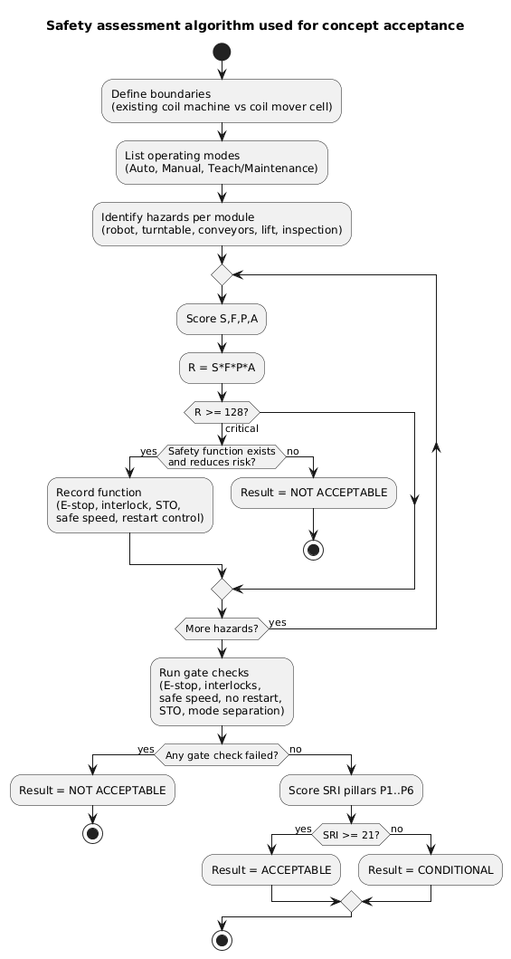
Figure 4: Safety Acceptance Workflow. This flowchart visualizes the decision logic used to validate the concept, moving from hazard identification to risk scoring, gate checks, and final SRI calculation.

3.2. Application to the Coil Mover Concept
The following analysis applies the methodology to the specific hazards identified in the module design.
- H1: Robot Motion (Work Envelope)
Score: S=4, F=3, P=3, A=4 → R=144 (Critical)
Required Mitigation: Fence around the robot with interlocked access; safety stop interface to robot controller; safe reduced speed monitoring during teach modes.
- H2: Circular Manipulator (Turntable) Pinch/Crush
Score: S=3, F=2, P=3, A=3 → R=54 (Medium/High Boundary)
Required Mitigation: Perimeter guarding around the turntable; STO interface to the drive; logic stops the table from turning unless the guard is closed and the safety state is valid.
- H3: Box Lift and Fixation (Trapping)
Score: S=3, F=3, P=3, A=3 → R=81 (High)
Required Mitigation: Fixed guarding at pinch points; "Jog" operation only permitted in manual mode with hold-to-run functionality; STO activation upon safety trip.
- H4: Conveyors (Entanglement/Nip Points)
Score: S=2, F=3, P=3, A=3 → R=54 (Medium/High)
Required Mitigation: Guarding of nip points; accessible E-stops located near infeed and outfeed zones; STO activation on safety trip.
- H5: Dropped Coil / Wire Snagging
Score: S=2, F=3, P=2, A=2 → R=24 (Medium)
Required Mitigation: Robust wire management (routing guides, keep-out zones);
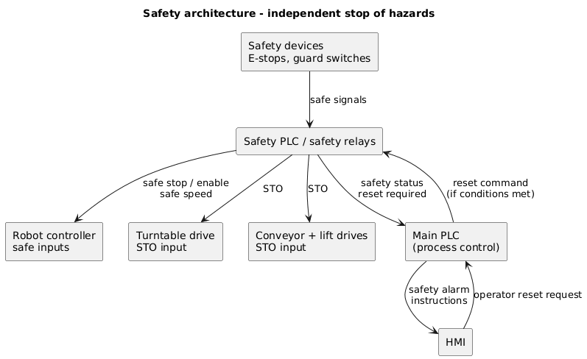Figure 5: Safety Logic and Mitigation Architecture. This diagram demonstrates the independent stopping mechanisms for hazardous elements, ensuring that safety signals (E-stops, STO) override process control signals.

3.3. Concept Assessment Status
Gate Check Results: The concept passes the mandatory gate checks. The design contains an E-stop chain, interlocked guarding, and safe reduced speed. Furthermore, the design separates the working zone for the operator and the robot’s safety zones.
SRI Score (Concept Phase):
- P1 (4/5): Hazards listed with the main risks being scored.
- P2 (4/5): Core safety functions defined as requirements.
- P3 (4/5): Architecture described and hardware is selected.
- P4 (3/5): A draft detailed validation plan is ready.
- P5 (2/5): Operational procedures/training are not written.
- P6 (4/5): High-level fault recovery defined.
Total: 22/30 (Acceptable)
Interpretation: The safety design is solid and meets the standards in the working field with the equipment present for this phase. The design is ready to move to detailed engineering.

4. Path to increase the SRI score
To move the system from "Acceptable" to "Ready for Production," the following items need to be finished in the next phase:
- Full Hazard List: A complete table showing risk scores for every single operating mode (Auto, Manual, Teach).
- Safety Map: A clear list that links every risk to its specific fix (for example: "Open Door → Robot Power Off").
- Detailed Test Plan: Step-by-step instructions to prove safety works, including:
  - Testing that E-stops kill power to the robot and drives.
  - Checking that opening a door stops movement immediately.
  - Verifying the machine won't restart without a manual reset.
  - Testing the "Safe Torque Off" on the box and turntable drives.
- Operator Guides: Instructions on the screen and in manuals for fixing common issues like jams or bad parts.
- Reset Guarding: A final drawing of the guard that covers the "mechanical reset" mechanism.

